Climate Review
Climate is the type of weather a place has over a long period of time. We describe climate based on the temperature (how hot or cold), precipitation (how much water it gets), and vegetation (what type of plants) a place has.
Factors Affecting Climate
Things that affect temperature are how far away a place is from the Equator, from the coast, and from mountains. Things that affect precipitation are whether a place receives moist or dry air and which side of a mountain a place is. Things that affect vegetation is the temperature and the precipitation. If a place is near a coast, then the temperature will be more stable and usually receives more moisture. If a place is on the windward side of a mountain, it will receive much rain because the mountain acts like a comb, pulling water from the air. If the place is on the other side of the mountain it will be really dry. The prevailing winds and ocean currents near an area have a big impact. For example, Europe seems like it should be colder because it is far from the Equator, but the ocean current in the Northern Atlantic around Europe is originally from the Gulf of Mexico. This makes Europe much warmer than its distance from the Equator would suggest. A place’s temperature also depends on its elevation. The higher up a place is, the colder it is.
Wind and Ocean Currents
Winds that blow in fairly constant patterns exist all over the Earth and are called prevailing winds. These winds can move cold air to warm places and warm air to cold places. Oceans have streams of warm water and cold water called currents. These work a lot like prevailing winds. Both prevailing winds and ocean currents affect climate in places near the oceans. Another way oceans affect climate is by keeping the temperature stable. In places near the ocean, there usually is not a big difference between its high temperature and its low temperature.
Latitude Zones
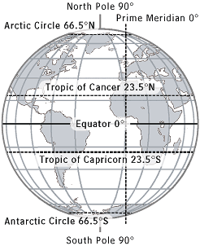
A place’s latitude has the biggest impact of its climate. If the place is between 23.5⁰ North and 23.5⁰ South, then it falls within the tropics. These lines of latitude show the part of the Earth that receives direct sunlight all year long. Because of this, the tropics are warm to hot all year long. The latitude zone between 23.5⁰ and 66.5⁰ (both North and South) are the middle latitudes. They are usually temperate (or mild or warm to cool) and very affected by other things like whether the place is close to a mountain or near the ocean or if it gets mostly dry air. The high latitudes found above 66.5⁰ (both North and South) are cold because they receive mostly indirect sunlight all year long.

Picture from http://www.infoplease.com/ipa/A0908193.html
Accessed September 2, 2013

