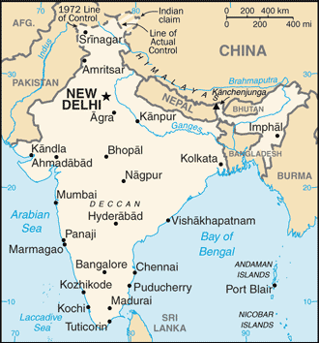
India: Rural Urban Migration
Some Basic Facts
India is home to 1.2 billion people. Of that number, 30% of the population lives in cities, or urban areas. The life expectancy is 67 years of age. The literacy rate is 61% (male-73.4%, female-47.8%). The infant mortality rate is 46 deaths per 1000. The GDP per capita is $3700. The labor force includes 52% in agriculture, 14% in industry, and 34% in services. The percent of children who are underweight is 43.5%. In many places in India, people belong to castes (or a position in society that is based on the occupation of the family). A person cannot change their caste regardless of what they do.
Rural Life
There are 600 million farmers who live in small villages throughout India. There is only so much farmland. That means that there is often not enough farmland for everyone who was born in the village. The people who get the farmland are often from higher castes. People in lower castes are often left to try to find jobs working for others in the village. But those jobs are only available some of the time for some of the people.
People in villages often go without or have to work very hard for things like clean water, food, or clothes. Clean drinking water is often difficult to find in the villages. Many times, families will keep one daughter from going to school so that she can spend her days getting the water her family needs throughout the day. Sometimes, the water source is over 10km away. Families in rural areas find it difficult to get good healthcare and education.
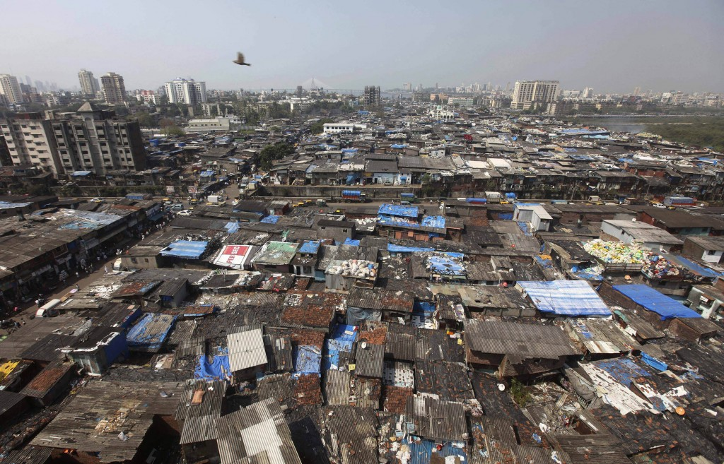
Urban Life
In urban areas, poverty is a major problem. Because of high birthrates and migration from rural areas the populations of the cities are often incredibly large. Because there are so many people and they are mostly poor, there are areas called slums in the cities where the poorest live. These slums lack clean water. Some people have no shelter at all. Rats and rodents are a huge problem. The ground and water are often polluted with dangerous chemicals. Unemployment is a major problem. Government officials make people pay money (or a bribe) before they will help the people by doing the job they were hired to do. In one slum of 3000 people, only six had permanent, full-time work.
Most people in the slums will try to find work as they can, taking whatever jobs come their way. If they are nearby, family or friends might help them find work opportunities. There are some ways to make enough money in the slums. Working part-time for other, wealthier people in the city is one way; another way is finding services people will pay for. One such service is the collecting of trash for recycling. People can find success in the slums. Even if they can’t find permanent work sometimes they figure out a way to make enough money to take care of their families. Some shelters will have TVs and other nice things. This helps other people believe that they might be able to be successful. People who need it have a better chance of government help like health care and grants of food. Another thing that helps the people who live in the slums is the fact that they are not as tied to tradition. People who belong to certain castes are only allowed to do certain kinds of work. This is a rule followed strictly in the rural areas but people may not notice what everyone is doing in the cities or care as much. Plus, if a person is not from the same village, then it is not clear what caste people are from.
Photo Sources
Map of India: CIA Factbook
Indian Slum: http://globalsiteplans.blogs.patsoffice.com/files/2013/07/Maxwell_Vidaver_11_07_2013_Image1-1024x657.jpeg
Rural Urban Migration
- What are two things you did not understand in the reading?
- In the “Basic Facts” Section, there are several statistics. What do those statistics basically say about India?
- Which statistics (2 or 3) were the most convincing for the conclusion you drew in question 3?
- There are about 350 million people in the United States. How many more farmers are there in India than there are people in the United States?
- What is a slum?
- In migration studies, a push is a reason why people leave the place they live. A pull is what makes them select the place they will live. Please complete the following with your research:
In India, living in rural areas is increasingly more challenging because (push factor 1), (push factor 2), and (push factor 3). The cities are often where migrants from the countryside move to because (pull factor 1) and (pull factor 2). In the city, recent migrants deal with the challenges of (a challenge of city life in India) and (another challenge).

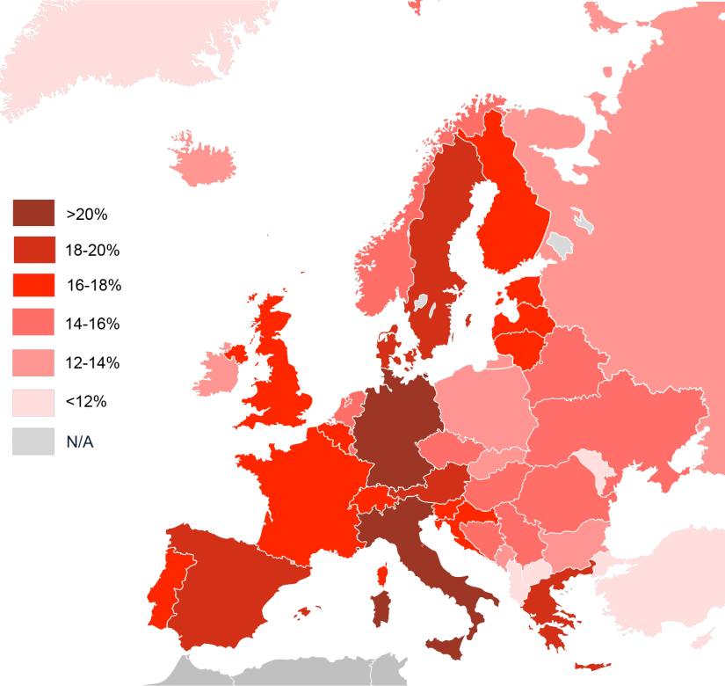
Europe: Negative Growth Rate and Cultural Tension
The continent of Europe is a densely populated place that includes countries like France, Germany, and Italy. Since World War 2, many of the countries have mixed market economic systems and democratic governments. Several countries of Europe also set up the European Union which is an agreement between some countries of Europe to combine their own little economies into one, big European economy. By having a big, successful economy, these countries would be able to compete with the United States’ giant, very successful economy. These decisions have resulted in the countries of Europe becoming quite wealthy. Life expectancies, GDP, and literacy rates are very high and infant mortality is low in most European countries. Because they are wealthy, many of these governments provide generous benefits to the people that live there.
Something strange happened in Europe after World War 2. In many countries, the population growth began to slow. Some countries began having a negative growth rate. A negative growth rate is where a country’s population gets smaller. People were not sure what might be the effects of a negative growth rate or why it was happening so quickly. Several countries tried to increase their growth rates by offering money to families who have more than one child. A major concern centered on the economy. If there are fewer and fewer people in the country, then their share of taxes increase if the governments are going to continue offering the same benefits that everyone wants. Remember, most of the systems are mixed markets, so that mean high taxes. Eventually, no one would be able to afford all the money they would have to pay in taxes.
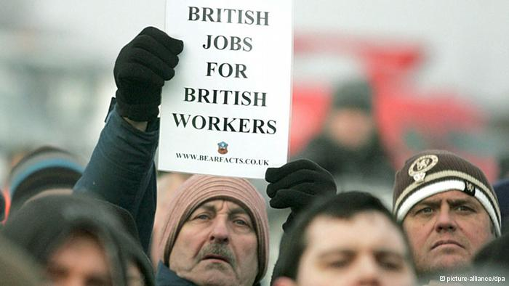
One strategy that many European countries used was to encourage immigration. People who immigrate to European countries join the work force and pay taxes. People who have immigrated are often able to find jobs and opportunities that they could not have found in their country of origin. It has positive benefits for both the country and to the people who migrate.
Unfortunately, this has not been a perfect solution. The people who have moved to Europe since World War 2 are increasingly different culturally than the people who live there. While some people move from one European country to another, many others come from beyond Europe. Most Europeans thought these individuals would work in Europe for a period of time and then return home. While that was true for many, some immigrants decided to live permanently in their new home. They had families and helped others from their country of origin to emigrate. Since they followed cultures that were different from the European cultures they found themselves in, they tried to bring as much of their culture with them as they could. Many European countries have found larger portions of their population follow different traditions, religions, and customs. For example, one of the largest non-European ethnicity on living in Europe is the Turks. The Turks are from Turkey and tend to follow Islam. These changes frighten many Europeans and, as a result, they argue that immigration policies need to change. Some people in Europe argue that new immigrants to Europe have caused increases in crime and terrorism or are just really different. Many people in Europe think multiculturalism is a negative thing. Recently, because the economies in Europe are having problems, this anti-immigrant argument has become more popular. In Greece, recent elections brought in a large number of people who belong to a party that has been connected to physical attacks and intimidation of immigrants to the country. In many other places in Europe, there are problems between native and immigrant groups.
Photo Sources
Immigrant Population Percentages in Europe Map: http://upload.wikimedia.org/wikipedia/commons/3/37/Europe_population_over_65.png
Anti-immigrant sign: http://www.dw.de/image/0,,17227429_303,00.jpg
Europe: Immigration and Cultural Tension Questions
- What two questions do you have about this reading?
- What does tension mean?
- What is the European Union?
- Why was the European Union created?
- What is a mixed-market system? What benefits can a citizen in a mixed-market system expect?
- Are the countries of Europe developed or developing?
- What is a negative growth rate?
- Compare the one-child policy in China to what many European governments have done.
- What is a possible economic effect of a negative growth rate?
- What does strategy mean?
- How do people in many European countries benefit from immigration to their country?
- What is a challenge for some people in many European countries because of high immigration rates to their country?
- What does multicultural mean? Can you think of an example in your own life?
- Why do people say they don’t like immigration to Europe?
- How do you think the immigrants would respond to these complaints?
- What do you think about what you have just read?

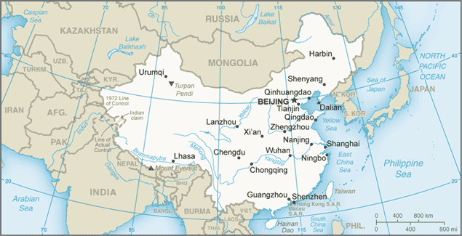
China’s One-Child Policy
The late 1970s was a time of major changes in China. The leaders of this communist country decided their economy would work better if they changed to more of a mixed-market economy (although the government stills makes a lot of the decisions, they do let people have more freedom). Another thing the leaders of China did in 1979 was to announce and enforce a one-child policy. The one-child policy was approved so that China could limit its population growth. At the time, the population was almost one billion. The leaders of China knew unless something was done, the population might get so large that it would be very difficult for the country to develop economically. With so many people, there would not be enough resources to go around.
The Chinese government does not apply the rule to everyone. It applies only to an ethnic group called the Han. The Han represent 91% of China’s population. Han Chinese who live in urban areas are required to have only one child. In rural areas, Han Chinese may get permission to have a second child if the first child they have is a girl. If two people are married and they are both only children, they are allowed to have two children. If a family has a child with major health problems they can usually get permission to have another child.
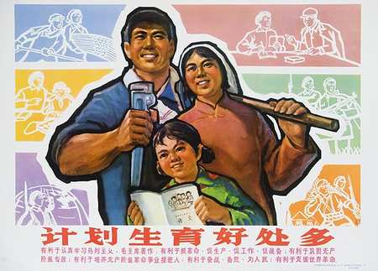
People who follow the policy can expect to be rewarded in other ways. Sometimes, they get better jobs or schooling and can often get loans or government assistance without too much trouble. People who have more than one child without permission are punished in several ways. They might be fired, fined, or be denied government assistance. In the past, the government might arrest women who did not follow the rules and force them. Another thing the government spends a lot of effort on is convincing people that their lives will actually be better if they have just one child. The government has been very successful in getting some groups of people to believe this idea.
The One-Child Policy has definitely made changes. The most important one is that China has been successful in limiting their population. If it had not been for the one-child policy, China’s current population would be around 1.65 billion people instead of the 1.35 billion it is now. They only grew by 138%. If they keep the policy, they will soon have a negative growth rate. To compare, India, which does not have such a harsh policy, has grown by 180% in the same amount of time. The economy in China is very strong and most people in the country live materially better than their parents did.
There are obvious problems with the one-child policy. One is that it does not allow people to make decisions about how they want their lives to be. Another big problem is that people, especially in rural areas want only boys. The reason for this is tradition. In the past, and in many places today, when a young couple marries, they move in with the man’s parents. Both the man and the woman are responsible for taking care of the man’s parents when they get old. That means that the woman’s parents do not really have anyone to take care of them. This is a big problem because most people in China want to treat their older family members with respect and care but there basically are not enough children to do that easily. Some families will end pregnancies if they find out they are having a girl. This concern for having boys also affects what people think about women. Because there is so much emphasis on having boys, boys are considered more important and better than girls.
Many people also wonder what will happen when all these children who have never had brothers or sisters become older. Will people who have no siblings act differently or have problems that children with siblings don’t have? Many people think the children will be very spoiled as the parents work very hard to make sure that their one child has all the opportunity possible.
Works Cited: http://geography.about.com/od/chinamaps/a/China-One-Child-Policy-Facts.htm
Photo Sources
Map of China: CIA Factbook
One Child Propaganda Poster: http://offbeatchina.com/wp-content/uploads/2012/06/2330-image-450-550-fit.jpg

One-Child Policy Questions
- What are two questions you have about what you have read?
- What is the One-Child Policy?
- Where is there a One-Child Policy?
- Who is affected by the One-Child Policy?
- When did the One-Child Policy begin?
- Why is there a One-Child Policy?
- How WAS the One-Child Policy enforced?
- How is the One-Child Policy enforced right now?
- Why is the One-Child Policy an important thing to study?
- What is an ethnicity?
- How many more people would China have now if they had not adopted the one-child policy?
- What is a negative growth rate?
- What does harsh mean?
- Should the tradition that prefers boys change or should the one-child policy change?
- What specific reasons do you have for what you answered in #9?

